CALL FOR PAPERS
for the
IGU CDES Conference
Organized by the College of Urban and Environmental Sciences, Peking University

Asia in the Transforming Global Economy
June 21 - 22, 2024, Beijing, China

Call for Papers
The world economy has radically changed over the past decade, especially in these uncertain times (COVID-19, technological disruptions, de-globalization, climate change, etc.). Against this background, Asian regions have become more and more important in the world economy and are increasingly at the center of various global crises and disruptions. This is coupled with some complex challenges for contemporary governance approaches (e.g., political alliance and state power) and institutional constructions when preventing the social and economic conflicts and inequality among various Asian regions. We also notice that the emerging technologies (e.g., Artificial General Intelligence and green technologies) have been crucial in the transformation of Asian economies.

While scholars have already directed their attention to the above aspects that are expected to deeply reshape the Asian and global socio-economic structure, a deeper understanding is still required. For instance, what key factors in Asian regions, including both economic and non-economic factors, are influencing the ongoing global economic transformation? How do different actors in Asia, such as firms, civil society, and governments, develop new roles in this transformative process? How does the process of global economic transformation decelerate (or accelerate) existing inequalities among regions in Asia?

This conference aims to bring together scholars interested in conceptualizing and empirically exploring the dynamics of Asian regions in the context of the transforming global economy. The contributions may explore, but should not be limited to, the following issues:
- New theoretical and methodological approaches to study the current transformation of economies emerging in Asian regions
- New roles of different actors in Asia during the transformation of (global) production network (GPN) and value chains (GVCs)
- Foreign direct investment (FDI) and multinational companies (MNCs) to and from Asia and their global and local impacts
- Transformation of economic sectors (e.g. agriculture, manufacturing, services) in Asia in relation with global economy
- The future evolutionary trajectories of different Asian regions in connection with GPN
- Existing and emerging economic inequality among different regions in Asia under the transformation of global economy
- The impacts of emerging new (e.g. Industry 4.0) technologies or the fourth industrial revolution on global economic transformation, particularly the potential changes in Asian and global economic structures
- Challenges of recent years (e.g. climate change, energy crisis, war conflicts) and their impact on Asian economies
- Urban and regional economic development policy and governance: role of institutions
- New development and innovation models for Asian core or peripheral regions
- Planning strategies to assist more sustainable economic growth in Asia

Submission of Papers
We invite submissions from academics, students, and individuals engaged in policy and practice. Our in-person event is designed to be inclusive, providing networking opportunities for everyone in our field.

Please send your abstract with 4 to 6 keywords (max. 250 words) to igu_cdes2024@163.com by April 1st, 2024, mentioning “paper submission for CDES2024” in the subject headline of the email.
For the convenience of organization, please include your detailed contact information (name, affiliation, phone number, as well as email address) in your submission.

The (selected) conference papers will be published in a book by IGU CDES. Please indicate in your abstract whether you are willing to submit the topic of your presentation as a book-chapter for the edited CDES book.

Key Dates
- Deadline for Abstracts: April 1, 2024
- Notification about acceptance: April 15, 2024
- Registration: March 15 – May 15, 2024
- Preliminary program: May 30, 2024
- Conference starts: June 21, 2024
- Full study submission for the book: July 15, 2024

Registration
All participants are required to make the registration.
Regular conference fee: 150 USD.
Reduced conference fee: 100 USD.
- The reduced conference fee is only available for students. Please send a proof of your status to the organizers (igu_cdes2024@163.com).
- The registration fee includes tea breaks, lunches, dinners and conference materials.
- Details about payment will be announced later. Payment can be made using VISA/Mastercard, Wechat Pay and Alipay.
- The organizers will provide invitation letters for visa applications upon request.

Venue
The conference will take place at:
College of Urban and Environmental Sciences, Peking University
located off the North Fourth Ring Road in Beijing’s Haidian District.
No.100 Zhongguancun North Street
Haidian District
Beijing 100871, P.R. China

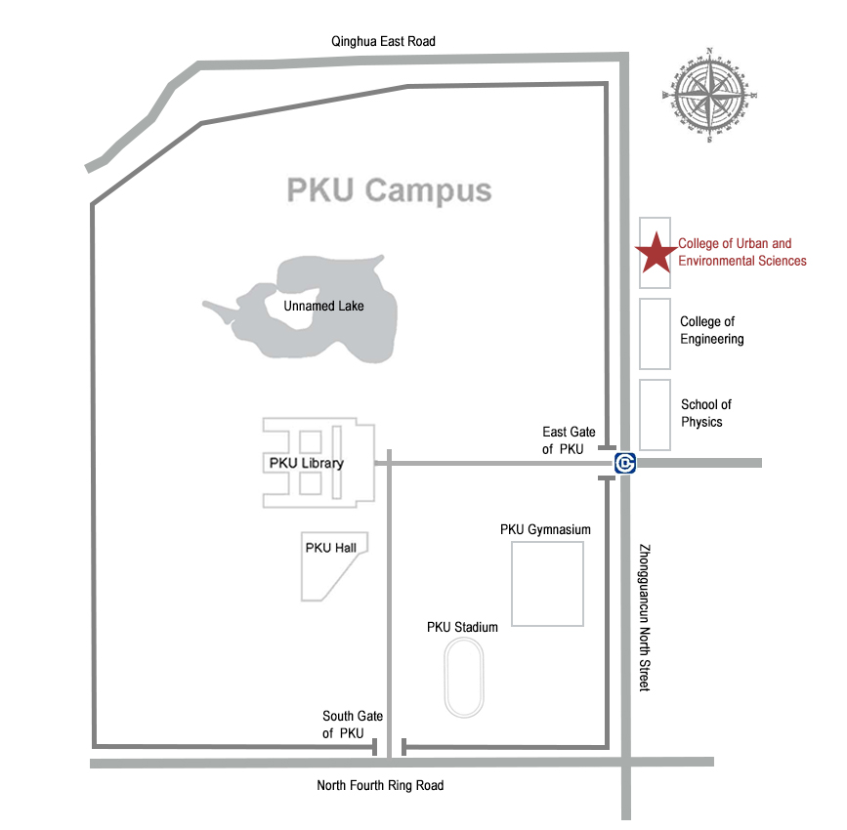

Accommodation
Accommodation must be booked individually and is not covered by the registration fee.
Recommended hotels:
High-end Hotels
1 | Zhongguanyuan Global Village | 北京大学中关新园
2 | Lake View Hotel | 北大博雅国际酒店
3 | Wenjin Hotel | 文津国际酒店
4 | Palace Hotel (Zhongguancun Suzhou Street) | 朗丽兹酒店（中关村苏州街店）
5 | Crowne Plaza Beijing Zhongguancun | 中关村皇冠假日酒店
6 | Ji Hotel (Zhongguancun Suzhou Street) | 全季酒店（中关村苏州街店）
7 | Crystal Orange (Zhongguancun Renmin University) | 桔子水晶酒店（中关村人民大学店）
Express Hotels
1 | Space Box (Peking University) | 慧佳酒店-盒子空间（北大店）
2 | Hanting Express (Zhongguancun Street) | 汉庭酒店（北京中关村店）
3 | Jifeng Express (Zhongguancun Suzhou Street) | 季枫精选酒店（中关村苏州街店）
4 | 7 Days Premium (Zhongguancun Renmin University) | 7天优品酒店（中关村人民大学苏州街地铁站店）

Getting to Conference Venue
- By Taxi: Take the North 4th Ring Road onto Zhongguancun North Street（中关村北大街）
- By Beijing Metro: Line 4 to East Gate of Peking University Station（北京大学东门站）
- By Beijing Bus: Over 20 bus routes that pass by PKU, including 106, 206, 718, 726, 732, and 808 bus routes. Look for East Gate of Peking University Station（北京大学东门）

Local Organizing Committee

For further inquiries, please contact Mr. Peifeng Zhang in the Local Organizing Committee.

Prof. Canfei He
Dean, College of Urban and Environmental Sciences
Peking University
Beijing, 100871, China

Dr. Shengjun Zhu
Associate Professor, College of Urban and Environmental Sciences
Peking University
Beijing, 100871, China

Mr. Peifeng Zhang
PhD student, College of Urban and Environmental Sciences
Peking University
Beijing, 100871, China
Email: zhangpeifeng@stu.pku.edu.cn

Websites of the conference: http://igu-cdes.mtafki.hu/

